***League of Women Voters of***

***New York State***

***Education Foundation, Inc.***

**Mission Statement**

The League of Women Voters of New York State Education Foundation, Inc. (LWVNYSEF) is strictly nonpartisan, and works primarily on projects that enlighten the electorate, i.e., *empower through education*, without advocating for any particular cause or policy, party or candidate. LWVNYSEF is committed to increasing citizen knowledge *of* and participation *in* their government. The LWVNYSEF believes that the basis of a strong democracy is an enlightened, educated citizenry.

***League of Women Voters of***

***New York State***

***Education Foundation, Inc.***

***62 Grand Street***

***Albany, NY 12207***

***518-465-4162***

***Fax: 518-465-0812***

***www.lwvny.org***

*E-mail: lwvny@lwvny.org*

#### *Youth Programs Sponsored by the League of Women Voters*

In addition to Students Inside Albany, local Leagues organize numerous other youth leadership and civic engagement programs, such as Take Me to Vote, Student Parent Mock Elections, Kids Voting USA, Running and Winning, and the Working Group on Girls.

For more information on how to participate in the *Students Inside Albany* conference, or any of our other programs listed above, please contact the League of Women Voters of New York State at 518-465-4162 or e-mail: lwvny@lwvny.org **or** contact your local League representative listed below.

***Frequently Asked Questions***

***About Students Inside Albany***

**How do you choose the students that will attend *SIA*?** Since each student is a representative of a local League and their community, the local League sets the criteria for sending a student. Each student may be asked to write about the conference for their sponsoring local League’s bulletin and may also be asked to be a special guest at one of their meetings.

**Is there any cost to the student?** No, LWVNYSEF, along with our cosponsors, pays for the entire conference, which includes lodging, meals and snacks. The local League that sponsors the student, is responsible for arranging and paying for transportation to and from the conference.

**How much time will I miss from school?** The conference starts on a Sunday afternoon and ends on Wednesday afternoon. So, the student will miss two, possibly three days of school.

***Students Inside Albany***

***Conference***

# *May 21-24, 2023*

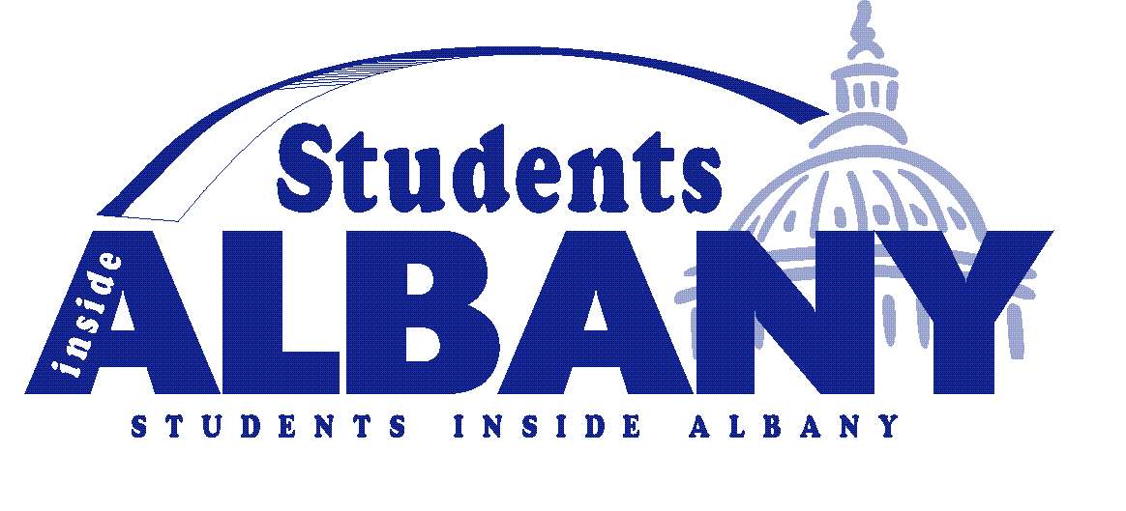

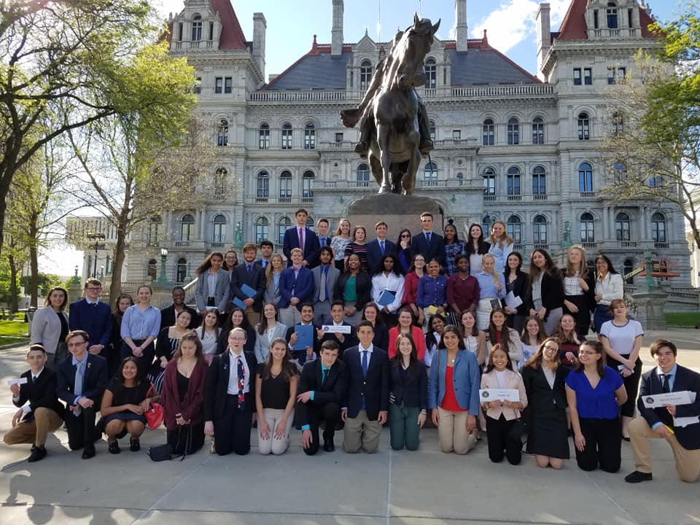

Sponsored by the

**League of Women Voters**

**of New York State**

Education Foundation, Inc.



FOR MORE INFORMATION CONTACT

League of Women Voters of

New York State

Office: 518-465-4162

E-Mail: Katrinalwvny@gmail.com



EF Logo Color

EF Logo Color

***What SIA graduates had to say about the conference:***

*“Everyone should be able to experience and learn about the behind-the-scenes process of their government.”*

*-2019 Participant*

*“Learned invaluable lessons about NYS government and being a more active citizen"*

*-2017 Participant*

*“It was an incredibly unique experience that I don’t think any other program could provide"*

*-2016 Participant*

*"You learn so much important information in a couple of days "*

*-2015 Participant*

*“If you are interested in government, you won’t get the connections & experiences anywhere else but SIA.”*

*-2017 Participant*

*"It’s one of the best things I’ve ever done. So interesting, so informative.."*

*-2019 Participant*

*“Made me more passionate about politics and gave me confidence to get more involved.”*

*-2018 Participant*

*“It’s life changing in the sense that you learn to listen and understand the opinions of others from all over even if they’re conflicting to your own.”*

*-2018 Participant*

***What is***

***Students Inside Albany?***

*Students Inside Albany* (SIA) is a conference sponsored by the League of Women Voters of New York State Education Foundation, Inc. The program is designed to increase students’ awareness of their responsibility in representative government and provide the tools necessary for meeting that responsibility.

This interactive conference will bring together high school students from across the state to learn about New York State government and the process by which citizens can participate in the policy making arena.

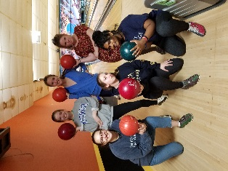

***What are the learning objectives of***

***Students Inside Albany?***

##### To increase student understanding of public policy in New York State.

##### To enhance student understanding of the roles of the various forces seeking to impact New York State legislation and policy development, enactment and change.

* To promote an increased understanding of the New York State legislative process through legislative shadowing experience.

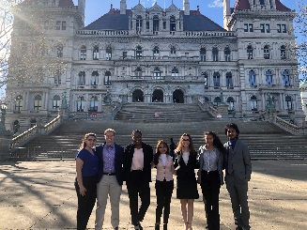

# *PAST CONFERENCE*

# *HIGHLIGHTS*

# Sunday

Registration

Welcome

Overview of Program

How Does NYS Government Work?

**Monday**

Tips for Being a Successful Citizen Lobbyist

Lobby Role-Playing with Legislators

Tour of the NYS Capitol

Students Shadow NYS Assemblymember

Media Perspectives on Public Policy Issues

Bowling and Social Activity

**Tuesday**

Political Activism: How Citizens Can Make a

Difference

Tour and Introduction to NYS Court of Appeals

Students Shadow NYS Senator

Social Activity

**Wednesday**

Recognition Breakfast

Voter Registration Basics

Conference Adjourned

